

GUILDWARS 2 HoT Heropoints Guide

Things you need to know about running HoT heropoints.

By Dancingbella

Exodus/z of the elder dragons/z [GODS]   EU based

## LFG

[Guildtag] HP Train xx:30 | Beginner friendly | VB>AB>TD

## /map

[Guildtag] Hero Points train, beginner friendly starting xx:30 at [&BN4HAAA=]! You just need raptor and basic gliding. To join squad go on LFG or type /sqjoin ‘’charactername’’

## Squad Message

Welcome to HP Train. You need a raptor and basic glide. Stack on ARROW for portal. Don’t panic if you got lost, just follow the markers on the map!

## Map Legends

Waypoints = Blue

Masteries = Green

Hero Points = Black

*HIGHLY recommend using Mesmers to lead HP trains as some places may require T3 bunny/updraft/bouncing mushrooms/flying mounts and are not as beginner friendly, especially if this is people’s first time on the map, it can get frustrating.

**It is always good to have another Mesmer as lieutenant to help with portals

***Optional to pick up masteries along the way

****Chopper lands xx:10 – 30. If needed, use choppers first to go to hard to reach masteries and HP like Vampire.

*****”Gliding Stops” are for beginners who do not have advanced gliding.

# Verdant Brink

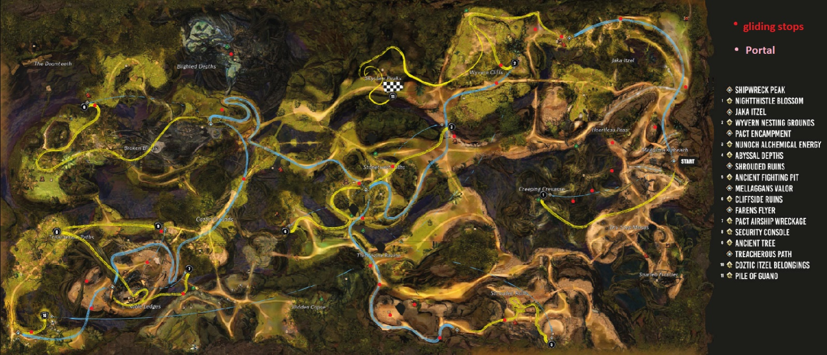

Start at **Shipwrek WP [&BN4HAAA=]**

1. **HP Nightingale Blossom and M Creeping Crevasse** = **Shipwrek WP [&BN4HAAA=]** . Glide off cliff to branch west of WP (1st gliding stop), drop down from the right and go under and stop on branch directly below (2nd stop). Pick up the strongbox on platform below (3rd stop). Drop straight down to the mastery along the way before dropping to the ground for HP.
2. **Jaka Itzel WP [&BOAHAAA=]** = from **Shipwrek WP** **[&BN4HAAA=]** Glide down north of wp, 1st stop on platform north of wp, 2nd stop on the fork and follow the eastest road and run along the path. Glide east towards WP.
3. **M Fumerol Caves =** from **Jaka Itzel WP [&BOAHAAA=]** glide down from in between the 2 giant huts east, pass the hill towards cave entrance on the ground. Stick to the right and walk pass bouncing mushroom to the end of the cave, clear mobs if needed, use bunny/glide/portal to reach mastery as mushrooms surrounding the area are poisonous.
4. **HP Wyvern Nesting Grounds** = from **Jaka Itzel WP [&BOAHAAA=]** . Glide east down to the slope, walk up the slope and follow the path. Once we reach the camp area, walk diagonally across towards bonfire, walk right side of bonfire to the cliff. We should see the HP below. Glide down. Clear mobs if needed.
5. **Pact Encampment WP [&BAgIAAA=] =** from HP Wyvern Nesting Ground, glide down the cliff to the west, go east across the bridge and just follow the path.
6. **M Thistlevine Ravine** = portal or springer/skyscale up the branch next to **Pact Encampment WP [&BAgIAAA=]**
7. **HP Nuhoch Alchemy Energy =** from **Pact Encampment WP [&BAgIAAA=]**, walk down the ramp and head north towards the cliff. Glide north, stop right next to the bridge pass all the beetles. Go to where HP shows on the map, drop down (a bit long). Alternatively use Nuhoch Wallows.
8. **HP Abyssal Depth =** from **Pact Encampment WP [&BAgIAAA=]** ,Glide south, walk across the bridge, walk along the east path, clear mobs if needed, stop where HP shows on map and drop all the way down. (again it is a long drop)
9. **M Creaking Cavern** = from **Pact Encampment WP [&BAgIAAA=] ,** walk as if we are going to Shrouded Ruins WP, at the red dot on map, drop down ONE level where mastery is shown on the map, right above water fall there’s a cave. Use bouncing mushroom or fly/portal.
10. **Shrouded Ruins WP [&BAEIAAA=]** = start from **Pact Encampment WP [&BAgIAAA=]** , glide down south and follow the path and up a hill. Clear mobs if needed.
11. **HP Ancient Fighting Pit** = from **Shrouded Ruins WP [&BAEIAAA=]** , follow path east, there are stairs on the east side, go up and follow path. Shortcut= just portal people up
12. **Mellaggan’s Valor WP [&BNUHAAA=]** = from **Pact Encampment WP [&BAgIAAA=]** , jump straight down into the NPC camp, and just follow path all the way up. Best to leave markers along the path. Clear mobs if needed.
13. **HP Cliffside Ruins** = **Mellaggan’s Valor WP [&BNUHAAA=]** , go east, turn right when we see a hill going down, just follow path all the way up cliff and then drop one level down on HP.
14. **M Corpse Grove = Mellaggan’s Valor WP [&BNUHAAA=] ,** walk north, at 1st stop glide down towards Blighted Depth. There should be a hole under one of the trees, jump down and glide immediately.
15. **Faren’s Flyer WP [&BO8HAAA=]** = from **Mellaggan’s Valor WP [&BNUHAAA=]** walk to east and jump off cliff. Glide along the path on map, and walk up hill. Leave markers on the floor if needed.
16. **M Outside Noble Ledges** = **Faren’s Flyer WP [&BO8HAAA=] ,** go up the side of cliff, at 1st stop glide to giant tree trunk, jump/walk/portal
17. **HP Pact Airship Wreckage =** from previous Mastery, glide/fly/portal
18. **HP Ancient Tree** = **Faren’s Flyer WP [&BO8HAAA=]** , walk north from WP, glide down and make 1st stop on a fat branch, and then glide all the way down inside a tree avoid poison when landing. Use portal to help people if they didn’t land on the HP.
19. **HP Security Countil** = **Faren’s Flyer WP [&BO8HAAA=]** = walk uphill to highest part, go inside the wreck and onto the giant tree branch. Walk on top of the tree branch and glide towards HP.
20. **Treacherous Path WP [&BBwIAAA=]** = **Faren’s Flyer WP [&BO8HAAA=]** walk southwest from WP to the edge of the cliff and glide west
21. **HP Coztic Itzel Belongings =** next to **Treacherous Path WP [&BBwIAAA=]**

**Choppers:**

1. **M Over Pact Encampment =** from **Pact Encampment WP [&BAgIAAA=]** chopper, go up the canopy, glide to platform where the boss is, glide to tree trunk, portal. Or if during day time, use the Shrouded Ruins WP route below.
2. **HP Pile of Guano/Vampire** = Use chopper to go up to canopy at **Jaka Itzel WP [&BOAHAAA=] ,** walk north until parallel to hp, glide.
3. **M Holdfast Hollow** = **Shrouded Ruins WP [&BAEIAAA=],** go w up stairs and use bouncing mushrooms/portal. Or canopy at pact encampment

# AURIC BASIN

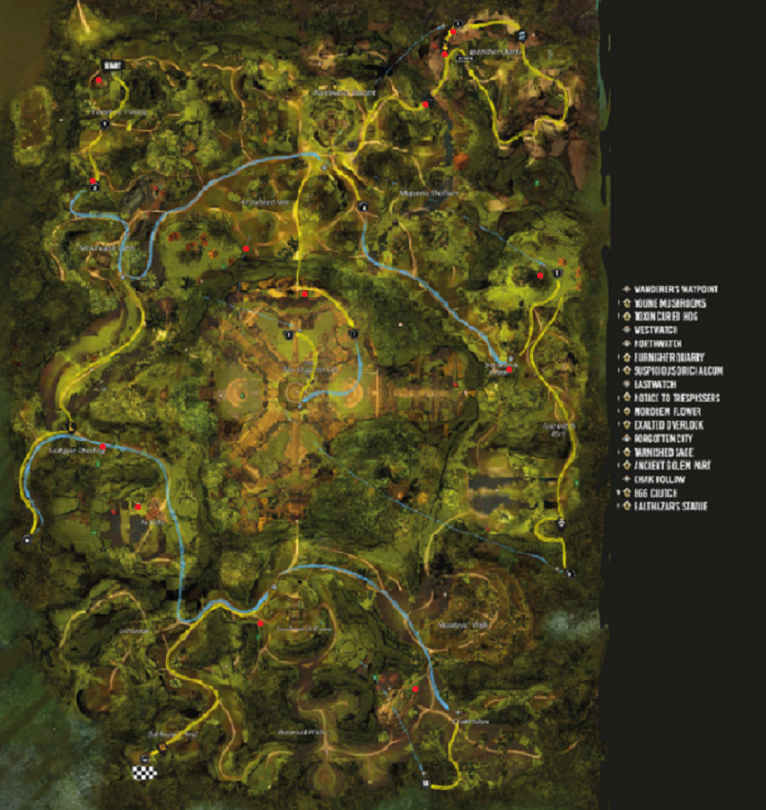

## LFG

[Guildtag] HP Train xx:30 | Beginner friendly | VB>AB>TD

## /map

[Guildtag] Hero Points train, beginner friendly starting xx:30 at [&BNYHAAA=]! You just need raptor and basic gliding. To join squad go on LFG or type /sqjoin ‘’charactername’’

## Squad Message

Welcome to HP Train. You need a raptor and basic glide. Stack on ARROW for portal. Don’t panic if you got lost, just follow the markers on the map!

*Help out Meta whenever possible. I usually take West Lane. Pick up the HP inside Forgotten City after meta and loot before continuing.

1. **Wanderer’s WP [&BNYHAAA=]** = start here
2. **HP Young Mushroom** = **Wanderer’s WP [&BNYHAAA=]** jump down and walk south
3. **HP Toxin-Cured Hod =** from HP Young Mushroom, walk south, there’s a hole in the ground, drop down. Use jackal for shield or skimmer for heals.
4. **West Watch WP [&BAYIAAA=]** = follow path south
5. **M Luminate’s Throne** = **West Watch WP [&BAYIAAA=]** enter through tarir west gate, turn R (S), use bouncing mushrooms, go up stairs
6. **M Masks of the Fallen = West Watch WP [&BAYIAAA=]** , walk along path towards north watch wp, need springer/portal
7. **North Watch WP [&BN0HAAA=]** = follow path north
8. **HP Exalted Overlook =** from **North Watch WP [&BN0HAAA=]** go inside the city, glide from tarir gate south east.
9. **HP Burnisher Quarry =** from **North Watch WP [&BN0HAAA=]** go to that ley-line gliding path but use portal/raptor instead to jump across cliff, go to where vista is, springer/portal up and walk to HP.
10. **HP Suspicious Orichalcum = North Watch WP [&BN0HAAA=]** go southeast and interact
11. **East Watch WP [&BGwIAAA=] =** go south from previous HP Suspicious Orichalcum, might need to portal up to wp. Chest S of WP on tree
12. **HP Notice to Trespassers** = go north from **East Watch WP [&BGwIAAA=]** , upstairs on jumping puzzle mushrooms, interact with signs
13. **M East Watch Bluff** = go southeast from **East Watch WP [&BGwIAAA=],** use portal/bouncing mushrooms.
14. **HP Mordrem Flower=** from mastery run south into cave and interact
15. **Forgotten City WP [&BMYHAAA=]**
16. **HP Champion Tarnished Sage** = from Forgotten City WP
17. **M Last Gear Standing = West Watch WP [&BAYIAAA=]**  go south, use springer/portal/bouncing mushroom up the platform.
18. **HP Ancient Golem Part =** go south from last mastery, there are bouncing mushrooms on the left side. Use them to go up. Once we are on the platform, go north and then west. Glide/fly/portal towards the branch west. Run into the cave.
19. **M The Falls** = same route from **West Watch WP [&BAYIAAA=]**  , but to the falls, glide/griffon/skyscale. Alternatively, get closer to on the platform to vista, portal people there.
20. **South Watch WP [&BAIIAAA=]** = go from **West Watch WP [&BAYIAAA=]**
21. **M Southwatch =** go from **South Watch WP [&BAIIAAA=]** Springer/fly/portal.
22. **HP Balthazor =** from **South Watch WP [&BAIIAAA=]** follow path. May need to portal people in if they don’t have exalted mark.
23. **Chak Hollow WP [&BEkIAAA=]** = go from **South Watch WP [&BAIIAAA=]**
24. **M Jawatl Grounds =** go from **Chak Hollow WP [&BEkIAAA=]** , run up the shipwreck, use portal/skyscale/springer
25. **HP Egg Clutch** = from **Chak Hollow WP [&BEkIAAA=]** , there’s a hole in the tree up there, go through and enter cave. Full dead wp.

*I left out the mastery where poison mastery is required.

# Tangled Depth

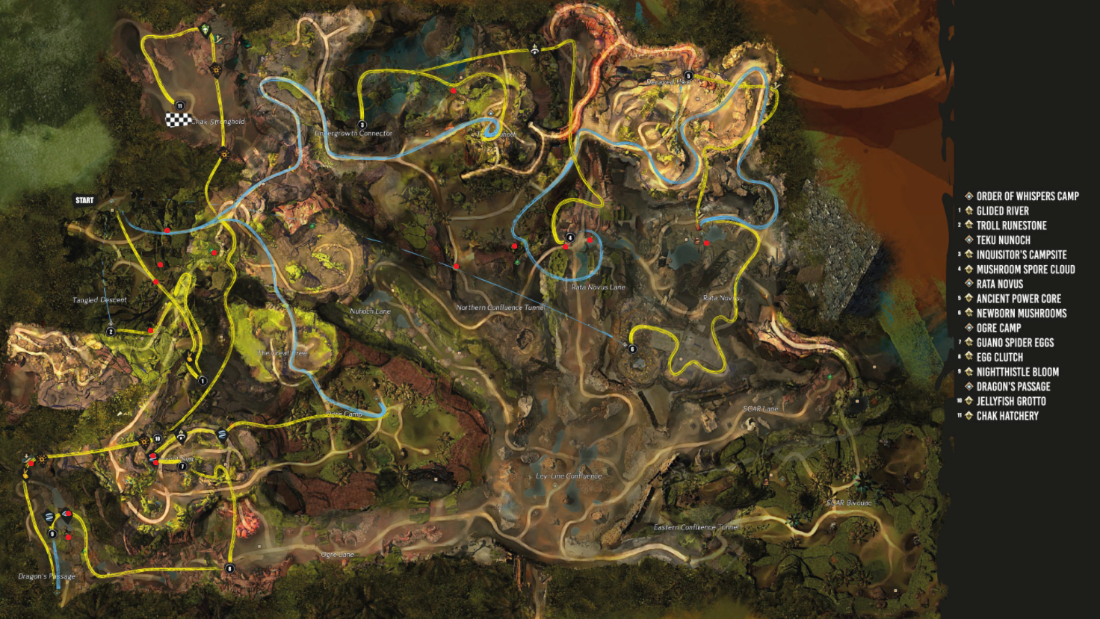

## LFG

[Guildtag] HP Train xx:30 | Updraft/T3 springer/flying mounts

## /map

[Guildtag] Hero Points train, starting xx:30 at [&BA4IAAA=]!You need updraft gliding, T3 bunny and preferably a flying mount (griffon/skyscale). To join squad go on LFG or type /sqjoin ‘’charactername’’

## Squad Message

Welcome to HP Train. You need updraft gliding, T3 bunny and preferably a flying mount (griffon/skyscale). Don’t panic if you got lost, just follow the markers on the map!

*Help out Meta whenever possible. I usually take Ogre Lane or Rata Lane, whichever one is close to where we are at the moment

**Don’t recommend for beginners who do not have updraft or at the minimum T3 springer as this route takes a lot of short cuts. The multiple layers and the number of mobs are not very friendly for those running on the ground so I highly recommend everyone has at least a griffon, or at the minimum, springer.

***One of the HP require poison mastery, or people will die immediately.

1. **Order of Whisper WP [&BA4IAAA=]** start here
2. **M Order of Whisper Outpost** from **Order of Whisper WP [&BA4IAAA=]** , go through the tree arch, drop down hole right next to river and glide down.
3. **HP Troll Ruinstone –** from last mastery, follow lower path west towards HP, always take the road on the right.
4. **HP Glided River =** from the **Order of Whisper WP [&BA4IAAA=]**, this is the short cut version, walk towards HP up onto a platform, go set a portal on platform to portal up the tree. Catch ALL The updrafts to the HP.
5. **HP Guano Incubated Spider Eggs =** from HP Glided River, take the closest updraft and go left around the corner. Rest on platform, then glide through leaves into the cave to 2nd stop. Take the closest updraft/fly towards HP.
6. **M Twisting Viaduct** = from HP Guano, walk SW to a tree branch right next to an updraft. Use updraft and glide west to tunnel that we see right in front of us. Slow drop down to a hole. Stop on the Mastery along the way.
7. **Dragon Passage WP [&BIgIAAA=]** = drop down more slowly from last Mastery Twisting Viaduct and glide/fly towards wp, don’t drop all the way down or will miss it. Can bunny up if we miss it.
8. **HP Nightthistle Bloom HP =** Bunny/portal up the platform North of **Dragon Passage WP [&BIgIAAA],** walk, use the first updraft to reach HP on platform. Or alternatively, fly with skyscale. Or portal people up.
9. **HP Jellyfish Grotto =** glide/walk north from previous HP, drop down the hole all the way into water and swim towards HP. Grab beacon on the way and stick close together.
10. **HP Egg Clutch =** from **Dragon Passage WP [&BIgIAAA=],** bunny up/skyscale/portal up the wall on the west of WP, go through Ogre Lane.
11. **Ley-Line Confluence [&BPUHAAA=] =** from Ogre Lane, go to this wp.
12. **Teku Nuhoch WP [&BAwIAAA=] = Order of Whisper WP [&BA4IAAA=]** walk the actual path on the floor through the tree arch, instead of dropping down the hole, go to the cave (along the path), to towards the WP and do downstairs into the cave
13. **HP Inquisitor’s Campsite =** from **Teku Nuhoch WP** **[&BAwIAAA=],** keep going up, up and up hill (before NPC camp) then straight across up a small hill, follow path up.
14. **M Northern Confluence =** from previous HP, glide down and follow path towards HP. Bunny/portal/skyscale to the first left bouncing mushrooms.
15. **HP Mushroom Spore Cloud** = 2 ways, take the 4th bouncing mushroom on the left and up the platform, bunny up. OR, on the ground, bypass all the mushrooms into cave up the hill through poison mushrooms.
16. **Rata Novus WP [&BAMIAAA=] =** back to **Ley-Line Confluence [&BPUHAAA=] ,** walk up north out to rata lane, turn right into Rata area and then just walk straight into WP.
17. **HP Ancient Power Core =** from **Rata Novus WP [&BAMIAAA=],** go into water, there’s an entry way DIRECTLY UNDER WP platform, go down all the way, TAKE A BEACON OR YOU WILL DIE, swim north and go up north, follow path. Either bunny/skyscale/portal people inside the lab.
18. **HP New Born Mushroom =** from previous HP facing it, bunny/skyscale/portal people into the next room, use Asura gate. It will either take you to next lab or back to wp (if there are events). Walk to the lab, on the southest wall there’s a blue arrow, bunny through the wall tunnel ledge and walk the RIGHTEST path low through tunnel to the mushroom cave.
19. **HP Chak Hatchery =** NEED poison mastery! Back to **Ley-Line Confluence [&BPUHAAA=],** go Nuhoch Lane, up jump across the wall, follow the path all the way.

*May need to complete event by Rata WP to reach New Born Mushroom.

**Other:**

**M Scar Lane** = from **Ley-Line Confluence [&BPUHAAA=],** there’s a bouncing mushroom all the way in Scar Lane. Use to bounce and glide to mastery.